**Assignment 1**

* **Problem Statement:** Create an account in AWS and configure a budget.
* **Steps:** For creating account in AWS.

1. First sign up in AWS account, provide email address and AWS account name.

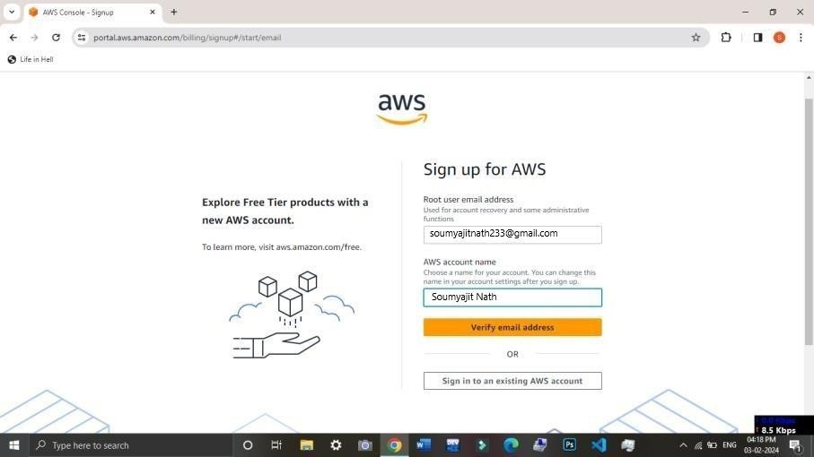

1. One code will appear in provided email. After that we have to copy that code and click on

‘Verify’.

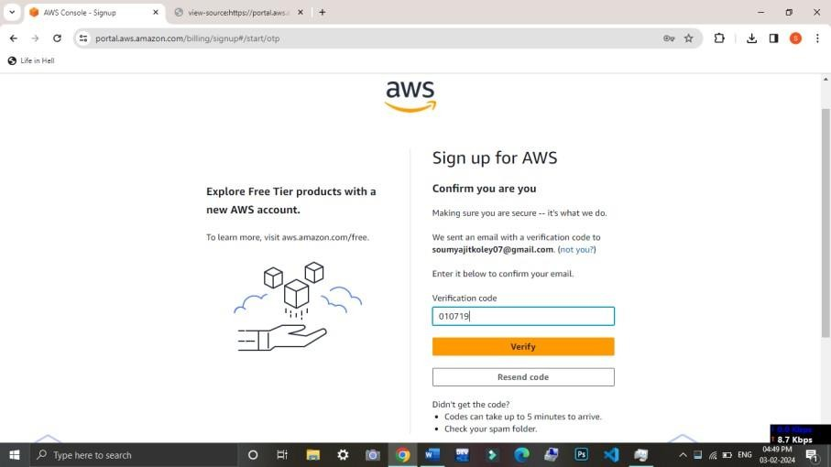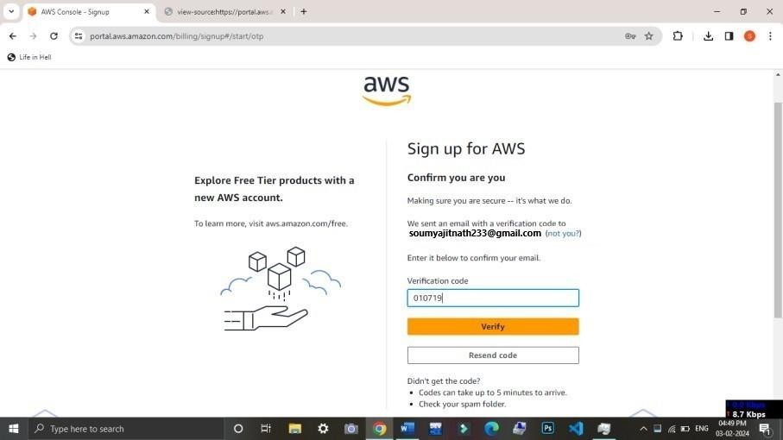

1. After that we have to set a password. Then click on ‘Continue (steps 1 of 5)’.

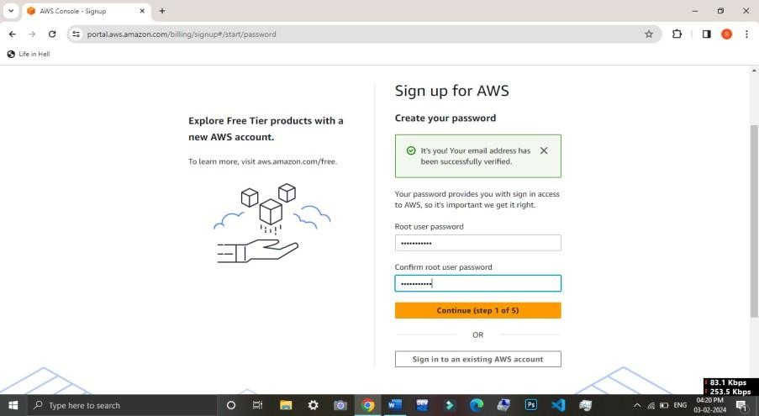

1. Then click on ‘Personal-for your own project’. Provide full Name, Mobile no. , Country , Address and City . Then click on the Customer Agreement checkbox and ‘Continue (step 2 of 5)’
2. After that one page will occur where we have to provide card(debit) details. Select the address then confirm PAN details. After that click on ‘Verify and Continue( step 3 of 5).
3. Then one OTP generate in mobile no we have to copy that and click on ‘Submit’.

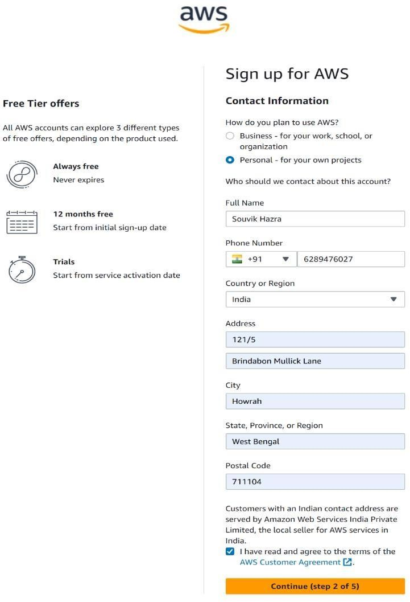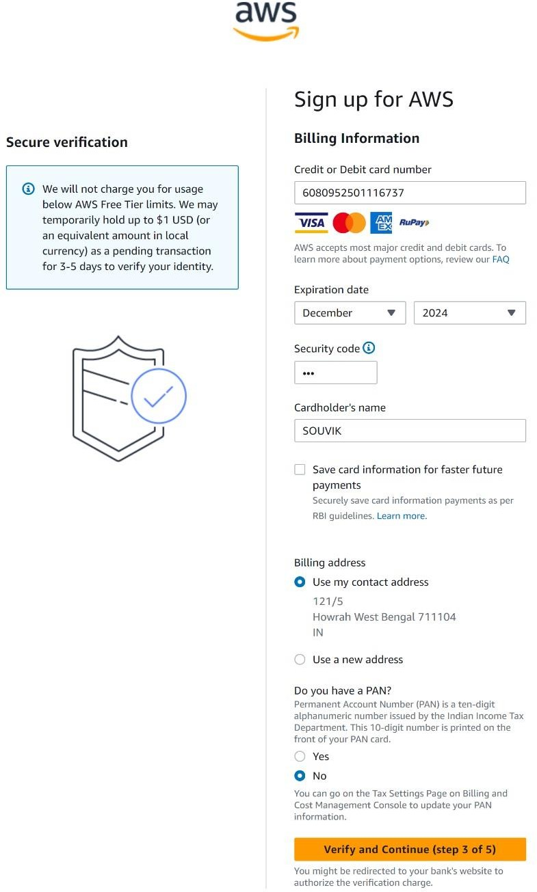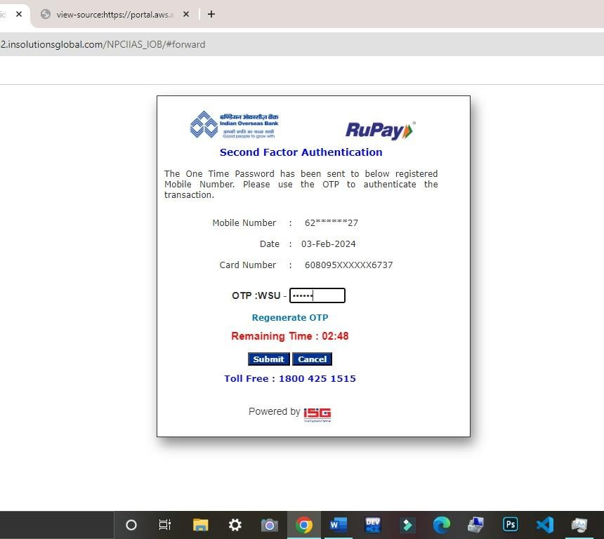

1. After submitting the OTP we have to confirm Name, purpose of account registration, Ownership type. Provide the PAN card Number and then click on ‘Continue (step 4 of 5)’.
2. Enter the captcha and then click on ‘Send

SMS (step 4 of 5)’.

Soumyajit Nath

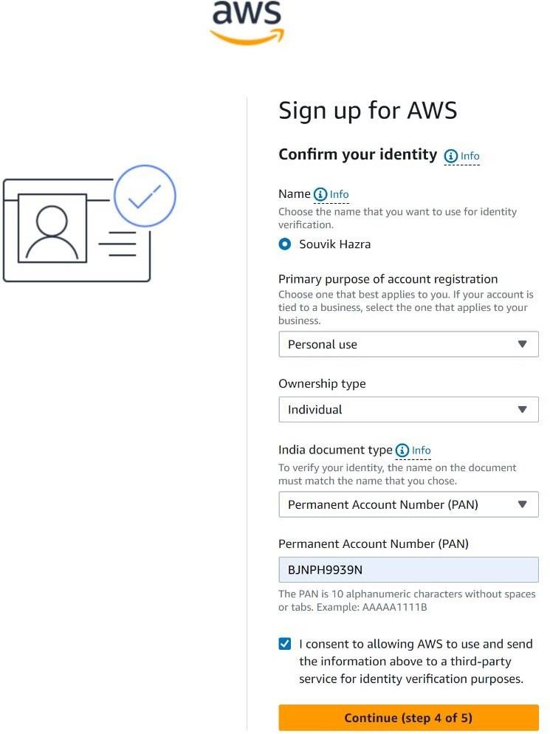 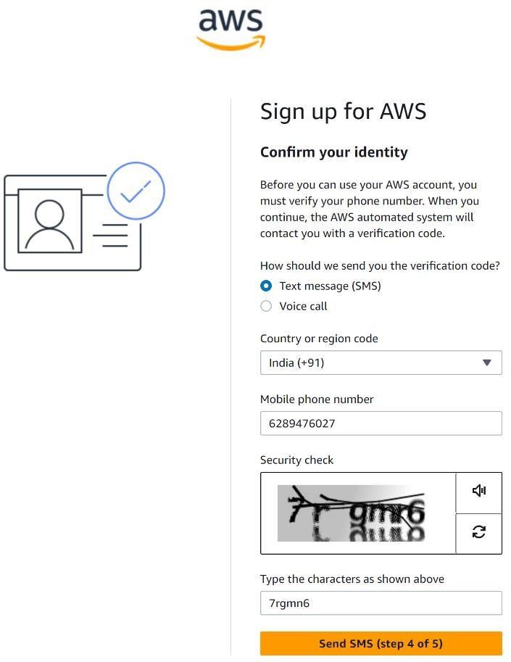

1. One OTP generate to the provided mobile number and we have to copy that and click on ‘Continue(step 4 of 5) ’.

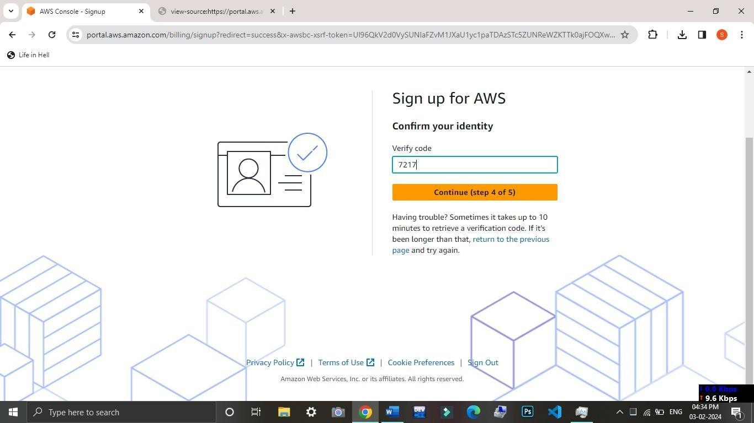

1. Select a support plan (Basic support - Free). Click on Complete sign up.

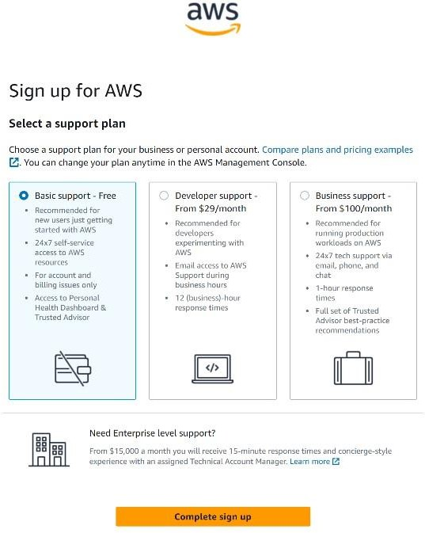

1. Account is created successfully. Go to the AWS Management Console.
2. 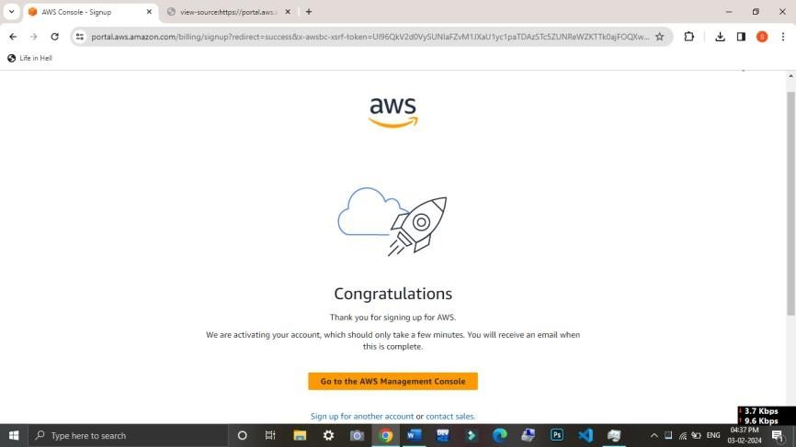After that login with same email id and password, we can a ‘Console Home’ page.

